KURO

Information for invitation to tender

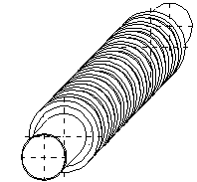
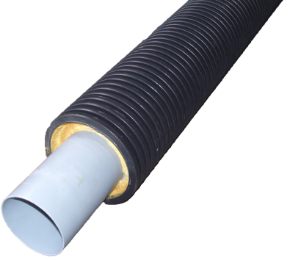
Product:

PVC Underground tube
- Material: PVC, PEHD (corrugated pipe)
- with composite insulation,
foamed
- also available with a smooth
outer tube

Text for Invitation to tender:

 | Pos: ....................... | PVC Underground tube 60 x 2.5 x 5000 mm – NW 55
 |  | with protective corrugated cover, foamed
 |  | System KURO or equal (www.kuro-kunststoffe.com),
 |  | deliver and assemble
 |  | Quantity: ............ m Price/Unit: .......... Price total: ..........
 | Pos: ....................... | PVC Underground tube 63 x 1.9 x 5000 mm – NW 63
 |  | with protective corrugated cover, foamed
 |  | System KURO or equal (www.kuro-kunststoffe.com),
 |  | deliver and assemble
 |  | Quantity: ............ m Price/Unit: .......... Price total: ..........
 | Pos: ....................... | PVC Underground tube 70 x 2.5 x 5000 mm – NW 65
 |  | with protective corrugated cover, foamed
 |  | System KURO or equal (www.kuro-kunststoffe.com),
 |  | deliver and assemble
 |  | Quantity: ............ m Price/Unit: .......... Price total: ..........
 | Pos: ....................... | PVC Underground Tube 80 x 2.5 x 5000 mm – NW 75
 |  | with protective corrugated cover, foamed
 |  | System KURO or equal (www.kuro-kunststoffe.com),
 |  | deliver and assemble
 |  | Quantity: ............ m Price/Unit: .......... Price total: ..........
 | Pos: ....................... | PVC Underground tube 90 x 2.0 x 5000 mm – NW 90
 |  | with protective corrugated cover, foamed
 |  | System KURO or equal (www.kuro-kunststoffe.com),
 |  | deliver and assemble
 |  | Quantity: ............ m Price/Unit: .......... Price total: ..........
 | Pos: ....................... | PVC Underground tube 108 x 4.0 x 5000 mm – NW 100
 |  | with protective corrugated cover, foamed
 |  | System KURO or equal (www.kuro-kunststoffe.com),
 |  | deliver and assemble
 |  | Quantity: ............ m Price/Unit: .......... Price total: ..........
 | Pos: ....................... | PVC Underground tube 110 x 2.3 x 5000 mm – NW 110
 |  | with protective corrugated cover, foamed
 |  | System KURO or equal (www.kuro-kunststoffe.com),
 |  | deliver and assemble
 |  | Quantity: ............ m Price/Unit: .......... Price total: ..........
 | Pos: ....................... | PVC Underground tube 125 x 2.6 x 5000 mm – NW 125
 |  | with protective corrugated cover, foamed
 |  | System KURO or equal (www.kuro-kunststoffe.com),
 |  | deliver and assemble
 |  | Quantity: ............ m Price/Unit: .......... Price total: ..........
 | Pos: ....................... | PVC Underground tube 132 x 4.0 x 5000 mm – NW 124
 |  | with protective corrugated cover, foamed
 |  | System KURO or equal (www.kuro-kunststoffe.com),
 |  | deliver and assemble
 |  | Quantity: ............ m Price/Unit: .......... Price total: ..........
 | Pos: ....................... | PVC Underground tube 160 x 3.2 x 5000 mm – NW 160
 |  | with protective corrugated cover, foamed
 |  | System KURO or equal (www.kuro-kunststoffe.com),
 |  | deliver and assemble
 |  | Quantity: ............ m Price/Unit: .......... Price total: ..........
 | Pos: ....................... | PVC Underground tube 200 x 4.0 x 5000 mm – NW 200
 |  | with protective corrugated cover, foamed
 |  | System KURO or equal (www.kuro-kunststoffe.com),
 |  | deliver and assemble
 |  | Quantity: ............ m Price/Unit: .......... Price total: ..........
 | Pos: ....................... | PVC Underground tube 315 x 6.2 x 5000 mm – NW 315
 |  | with protective corrugated cover, foamed
 |  | System KURO or equal (www.kuro-kunststoffe.com),
 |  | deliver and assemble
 |  | Quantity: ............ m Price/Unit: .......... Price total: ..........

